N : Total sample size (x-axis on graphs)

$p_{0}=0.85$: recovery rate under the null. It was estimated from district_wise.csv.

$H_{0}$: All group have recovery rates of $p_{0}$.

**3T vs 1C**

|  |  |  |  |  |
| --- | --- | --- | --- | --- |
|  | **T1** | **T2** | **T3** | **C** |
| $$H_{0}$$ | $$p_{0}$$ | $$p_{0}$$ | $$p_{0}$$ | $$p_{0}$$ |
| $$H_{1}$$ | $$p_{0}$$ | $$p_{0}+d$$ | $$p_{0}+2d$$ | $$p_{0}$$ |

i) d = 0.01

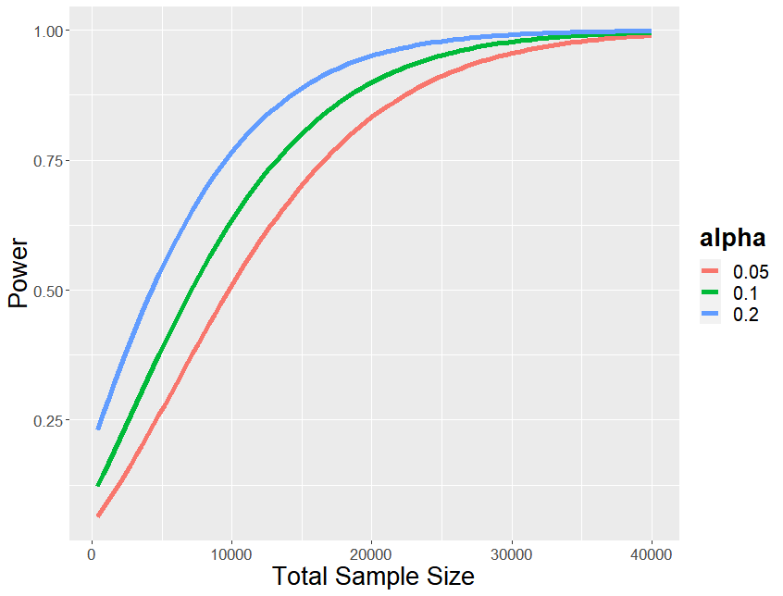

ii) d = 0.03

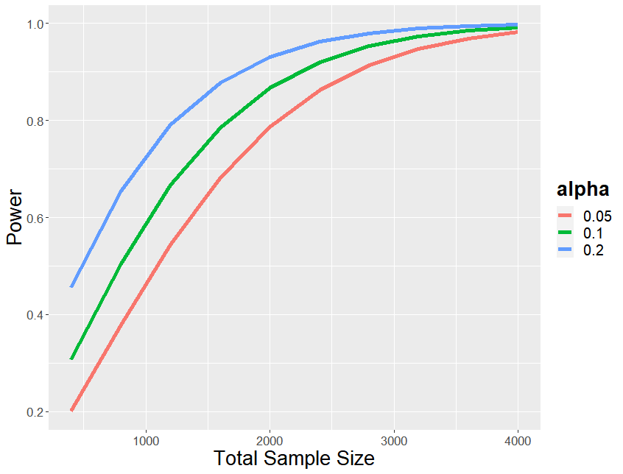

ii) d = 0.05

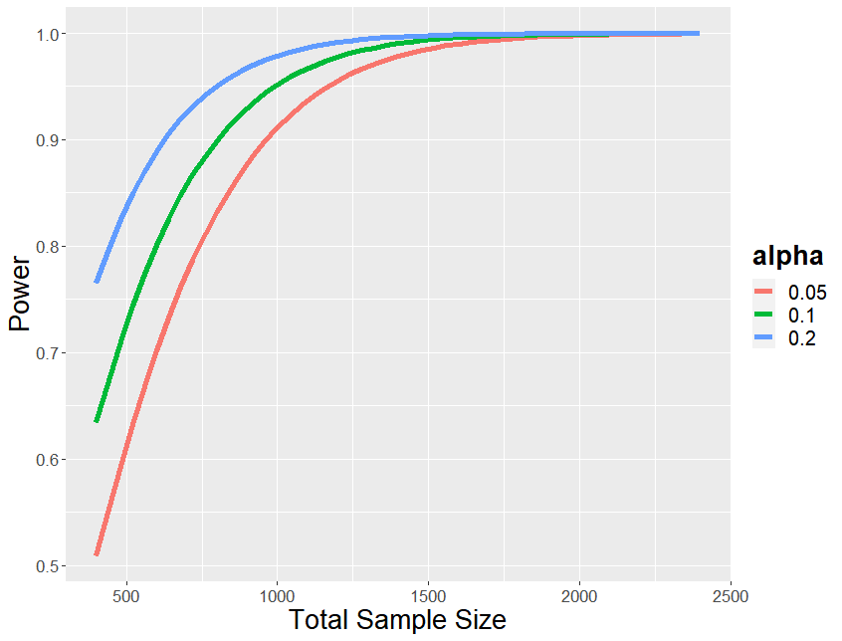

**3T vs 3C**

|  |  |  |  |  |  |  |
| --- | --- | --- | --- | --- | --- | --- |
|  | **T1** | **T2** | **T3** | **C1** | **C2** | **C3** |
| $$H_{0}$$ | $$p_{0}$$ | $$p_{0}$$ | $$p_{0}$$ | $$p_{0}$$ | $$p_{0}$$ | $$p_{0}$$ |
| $$H_{1}$$ | $$p_{0}$$ | $$p_{0}+d$$ | $$p_{0}+2d$$ | $$p_{0}-e$$ | $$p_{0}$$ | $$p_{0}+e$$ |

i) d = 0.03, e=0.01

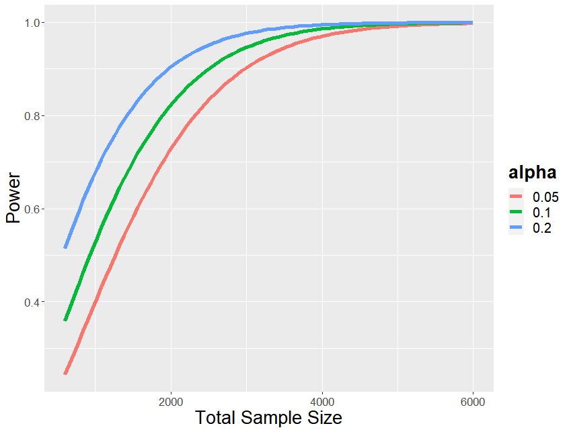

ii) d = 0.03, e=0.03

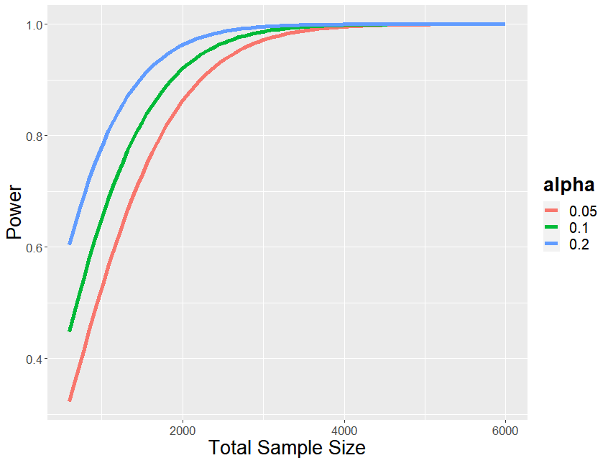

iii) d = 0.05, e=0.01

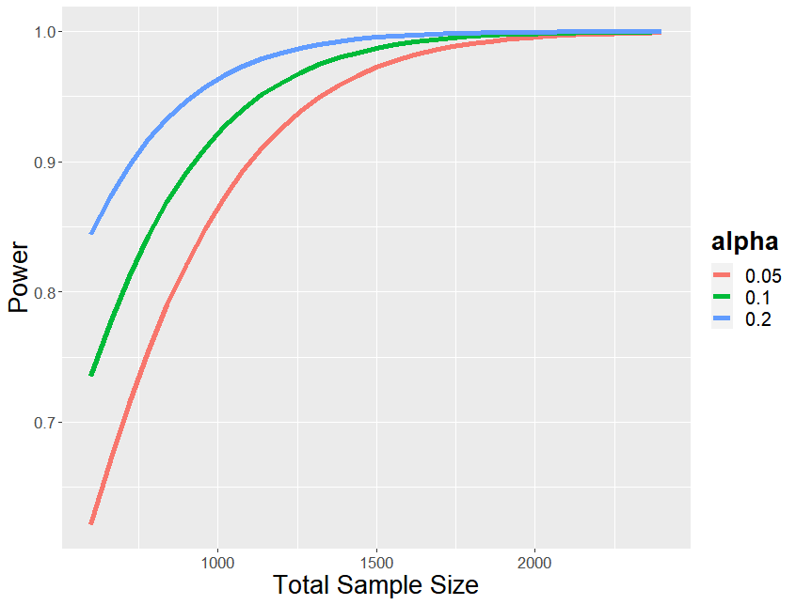

iv) d = 0.05, e=0.03

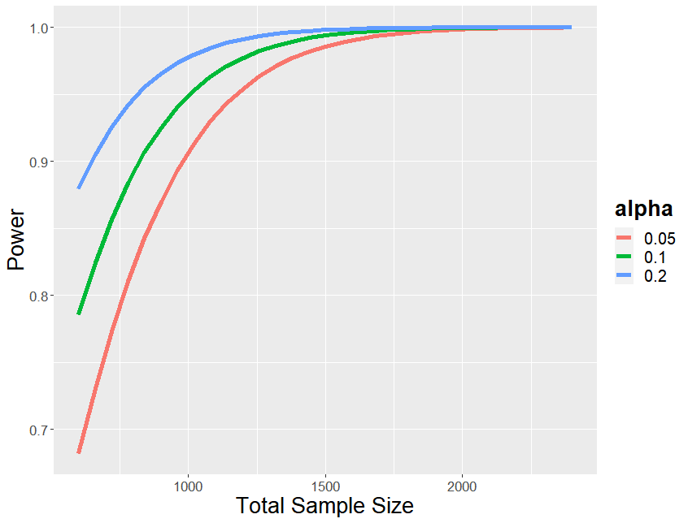

v) d = 0.05, e=0.05

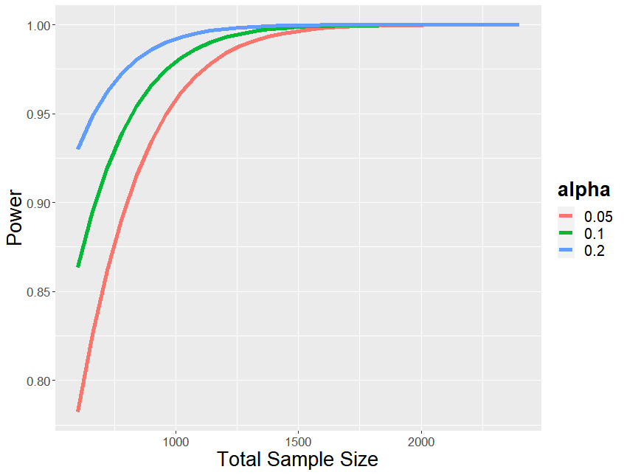

**3T vs 2C**

|  |  |  |  |  |  |
| --- | --- | --- | --- | --- | --- |
|  | **T1** | **T2** | **T3** | **C1** | **C2** |
| $$H_{0}$$ | $$p_{0}$$ | $$p_{0}$$ | $$p_{0}$$ | $$p_{0}$$ | $$p_{0}$$ |
| $$H_{1}$$ | $$p_{0}$$ | $$p_{0}+d$$ | $$p_{0}+2d$$ | $$p_{0}-e$$ | $$p_{0}+e$$ |

i) d = 0.03, e=0.01

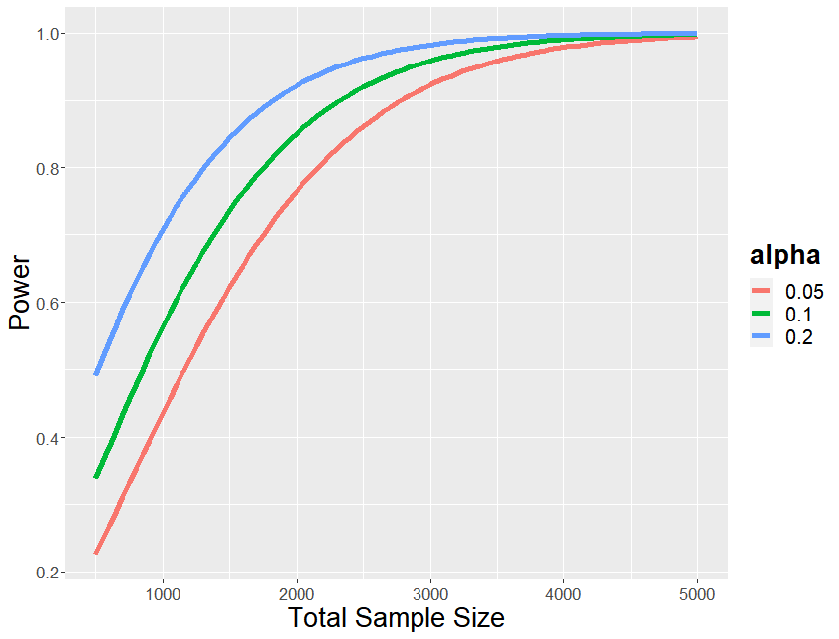

ii) d = 0.03, e=0.03

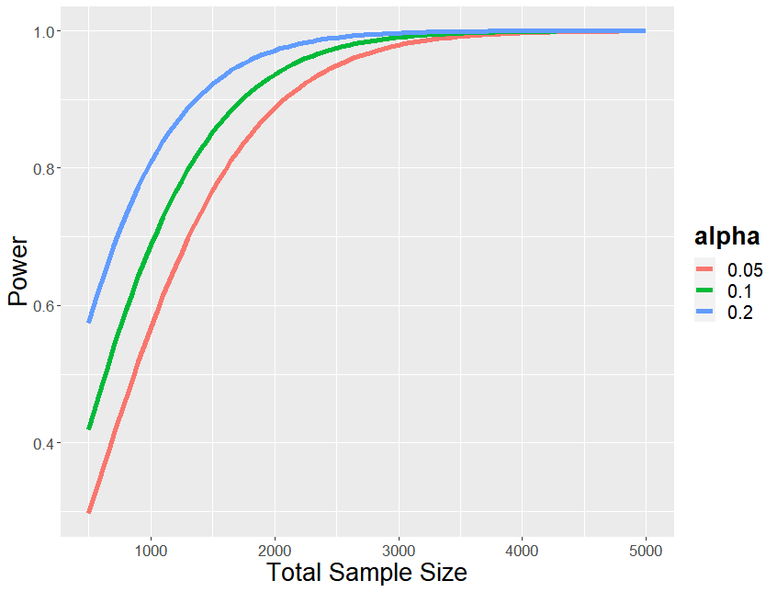

iii) d = 0.05, e=0.01

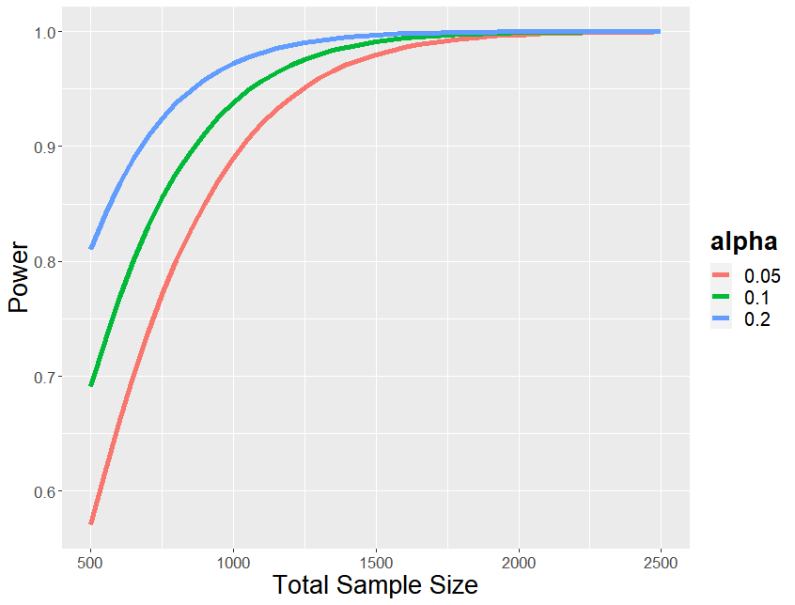

iv) d = 0.05, e=0.03

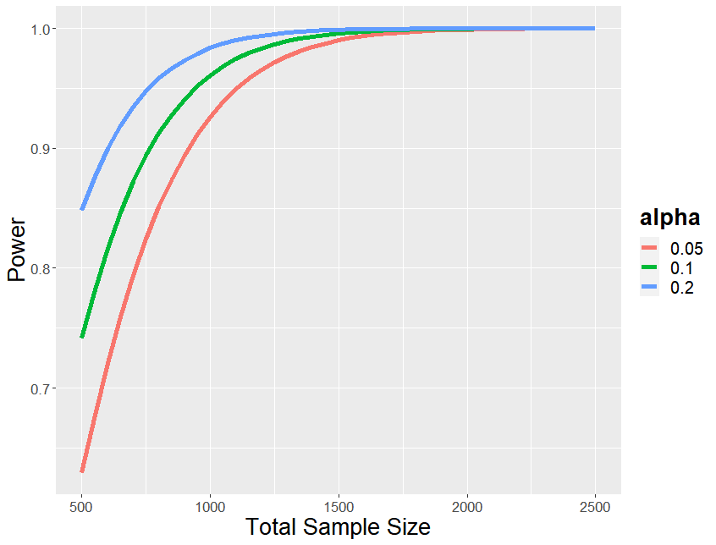

v) d = 0.05, e=0.05

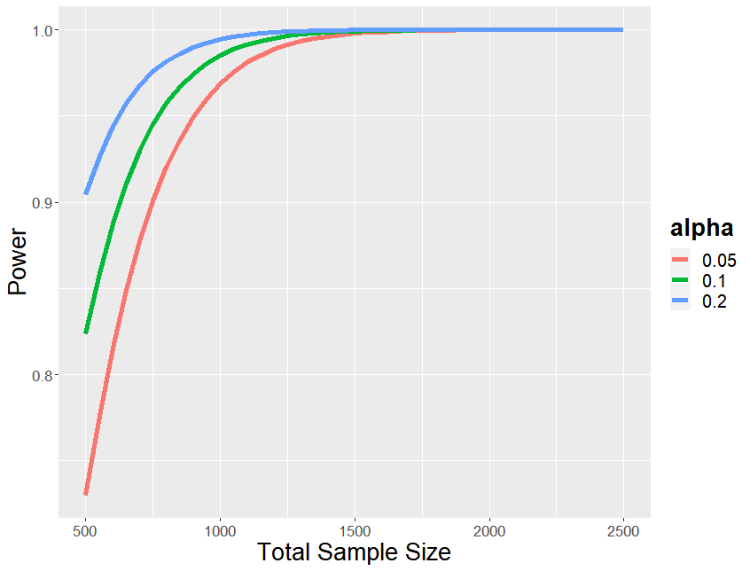

**2T vs 2C**

|  |  |  |  |  |
| --- | --- | --- | --- | --- |
|  | **T1** | **T2** | **C1** | **C2** |
| $$H_{0}$$ | $$p_{0}$$ | $$p_{0}$$ | $$p_{0}$$ | $$p_{0}$$ |
| $$H_{1}$$ | $$p_{0}$$ | $$p_{0}+d$$ | $$p_{0}-e$$ | $$p_{0}+e$$ |

i) d = 0.03, e=0.01

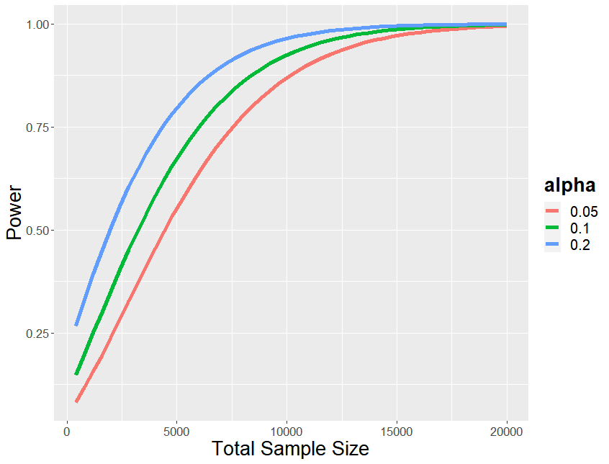

ii) d = 0.03, e=0.03

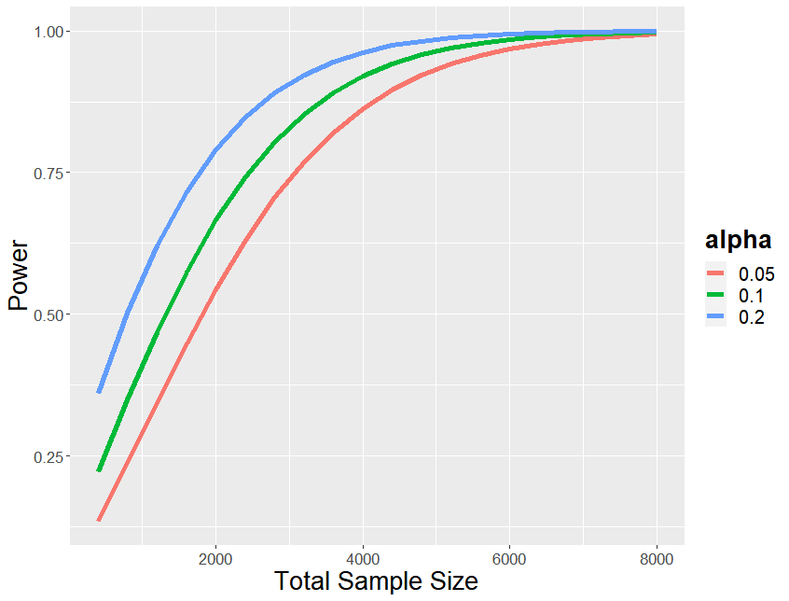

iii) d = 0.05, e=0.01



iv) d = 0.05, e=0.03

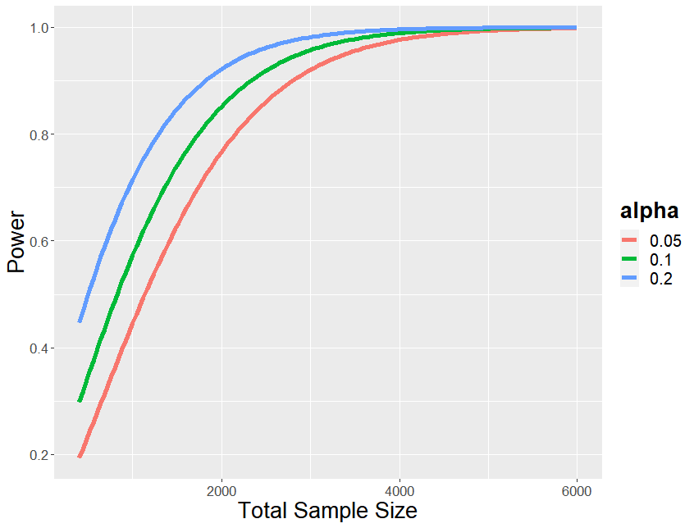

v) d = 0.05, e=0.05

